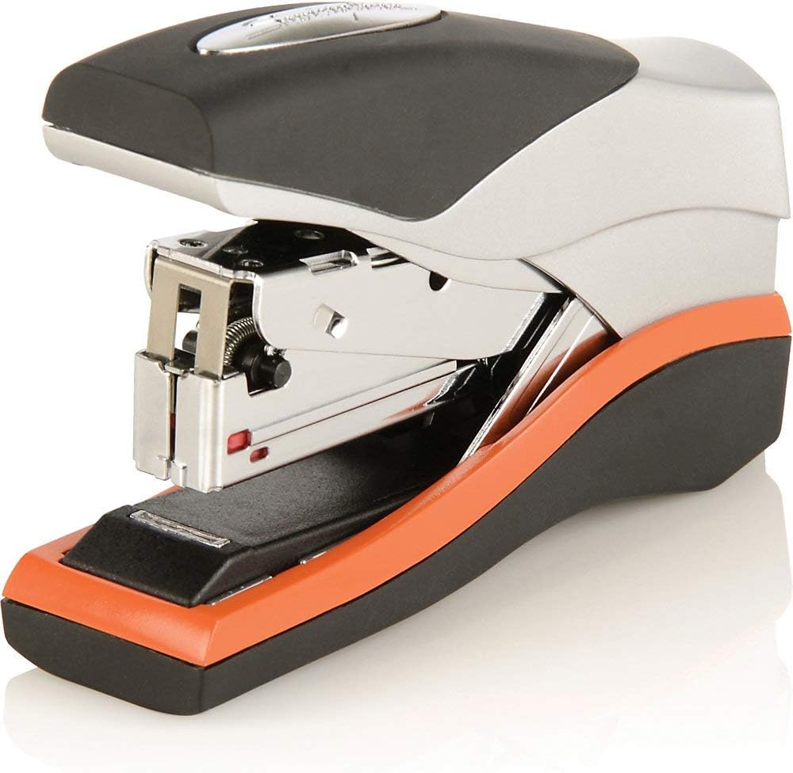

Montblanc Meisterstück Stapler:

The Montblanc Meisterstück Stapler combines timeless design with functionality. Crafted from high-quality materials, it fastens documents seamlessly. As part of the revered Meisterstück collection, it embodies luxury and tradition.